**Practical No 6**

**Description:**

Selenium IDE (Integrated Development Environment) is the simplest tool in the Selenium Suite. It is a Firefox add-on that creates tests very quickly through its record-and-playback functionality. This feature is similar to that of QTP. It is effortless to install and easy to learn.

**Aim: Selenium: Introduction, Installing Selenium IDE, Installing Firebug Plugin, Installing FirePath (****ChroPath).**

**Theory:**

Selenium IDE (Integrated Development Environment) is the simplest tool in the Selenium Suite. It is a Firefox add-on that creates tests very quickly through its record-and-playback functionality. This feature is similar to that of QTP. It is effortless to install and easy to learn. Because of its simplicity, Selenium IDE should only be used as a prototyping tool, not an overall solution for developing and maintaining complex test suites. Though you will be able to use Selenium IDE without prior knowledge in programming, you should at least be familiar with HTML, JavaScript, and the DOM (Document Object Model) to utilize this tool to its full potential. Knowledge of[JavaScript](https://www.guru99.com/interactive-javascript-tutorials.html)will be required when we get to the section about the Selenese command "**runScript."** Selenium IDE supports autocomplete mode when creating tests. This feature serves two purposes:

* It helps the tester to enter commands more quickly.
* It restricts the user from entering invalid commands.

**Steps for installing Selenium IDE:**

**Steps 1:** Lunch Edge and then go to chrome web store search for Selenium IDE, then click on add to chrome as show in the image below.

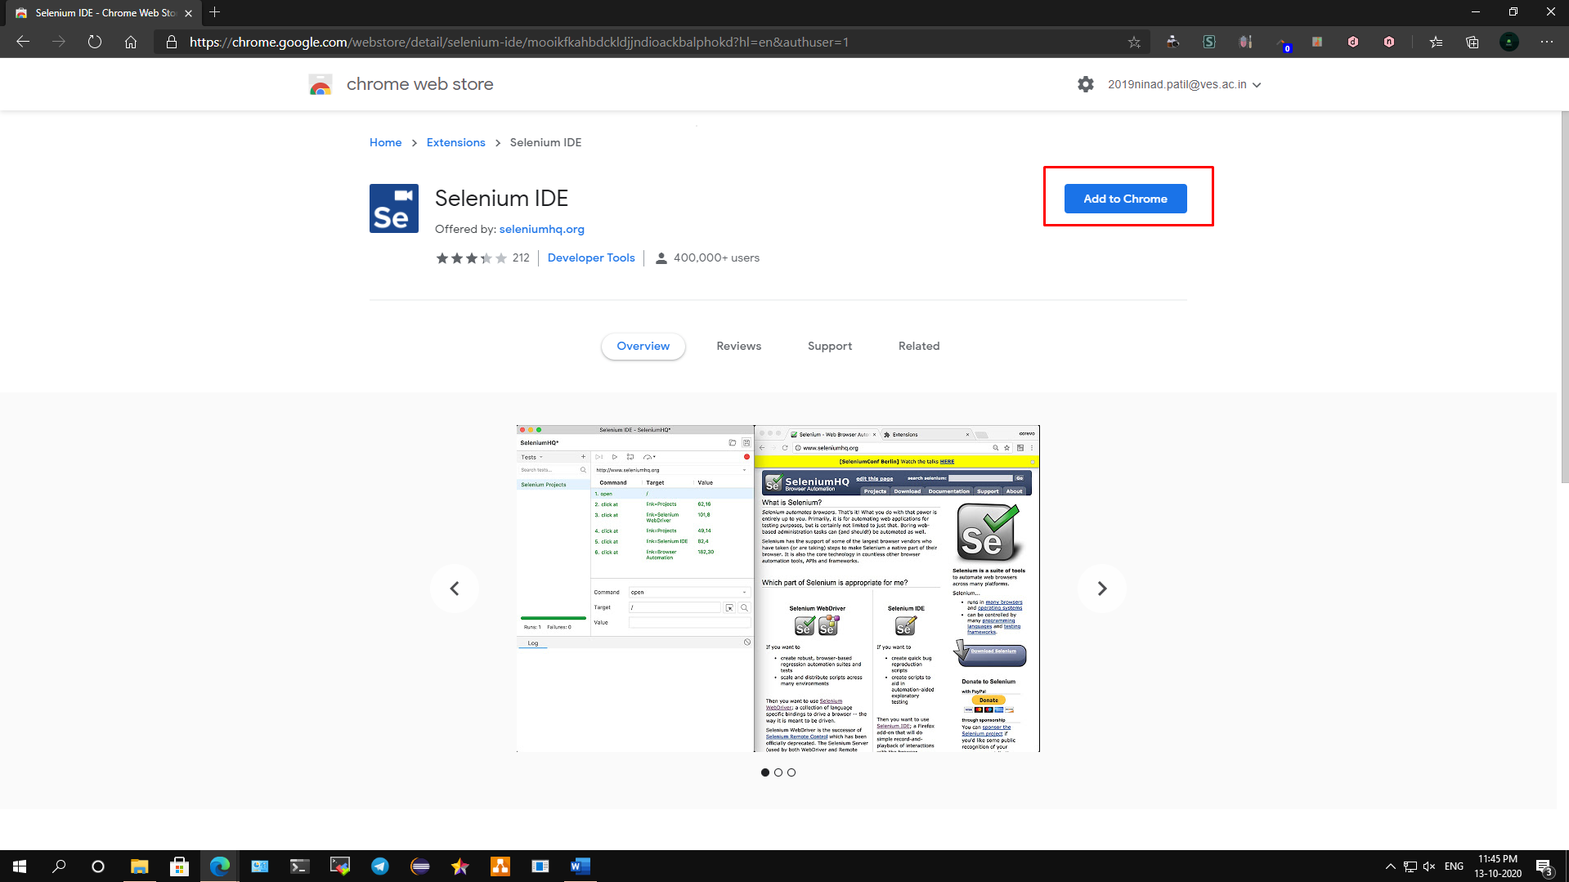

**Steps 2:** Edge will show one popup asking if you want to add extension or not. Click on Add extension button as show in image below.

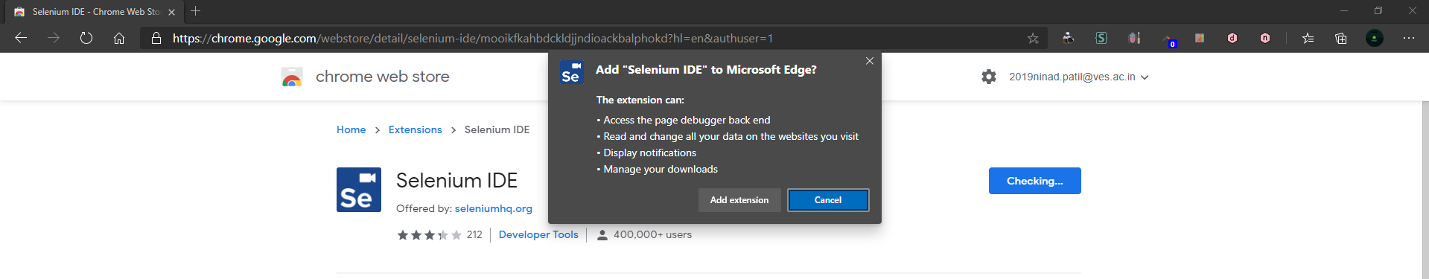

**Steps 3:** Edge will automatically add Selenium IDE extension. Once it added, we can see selenium IDE on the toolbar menu. Click on that Selenium IDE (marked with red box) and it will open it.

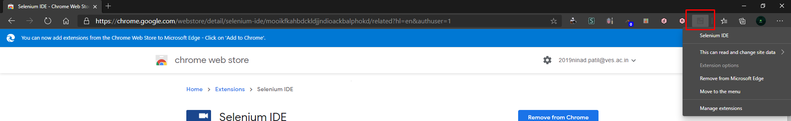

**Steps 4:** Click on Selenium IDE, it will launch Selenium IDE.

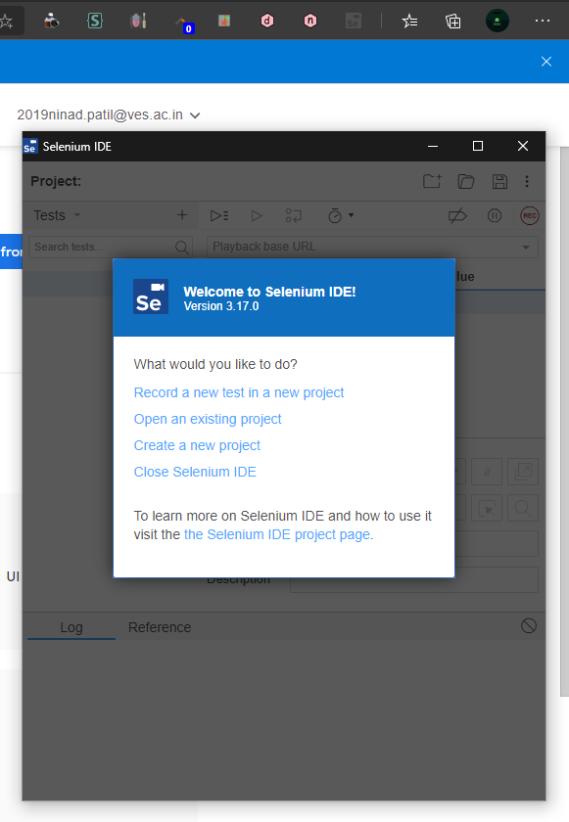

**Steps for installing Firebug Plugin:**

**Steps 1:** Lunch Edge and then go to chrome web store search for Firebug Lite, then click on add to chrome as show in the image below.

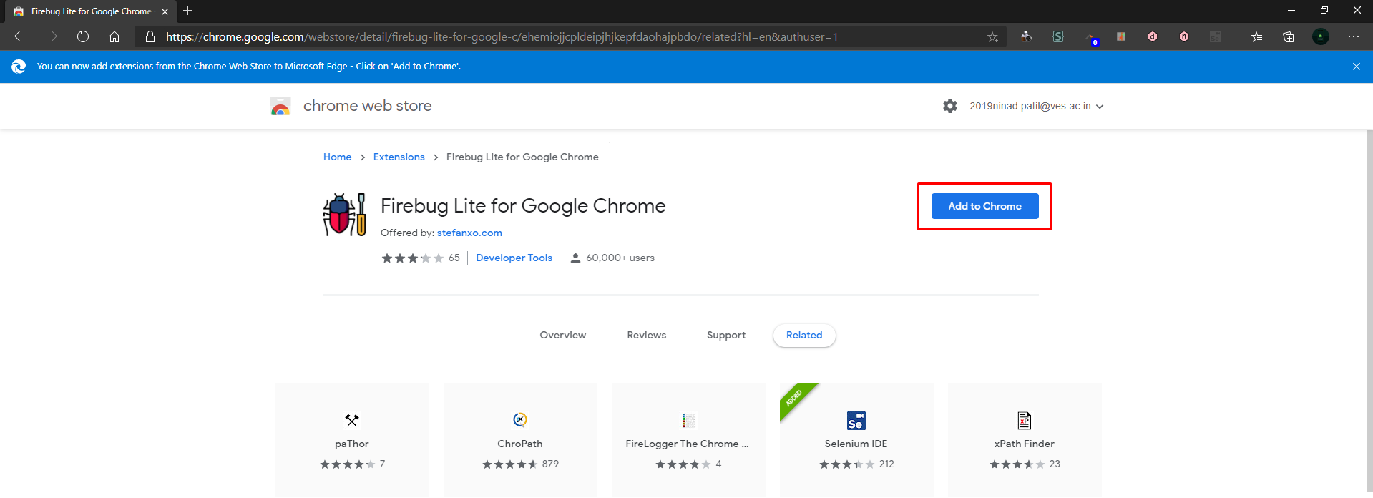

**Steps 2:** Edge will show one popup asking if you want to add extension or not. Click on Add extension button as show in image below.

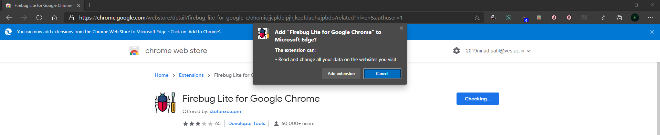

**Steps 3:** Edge will automatically add Firebug Lite extension. Once it added, we can see Firebug Lite on the toolbar menu. Click on that Firebug Lite (marked with red box) and it will open it.

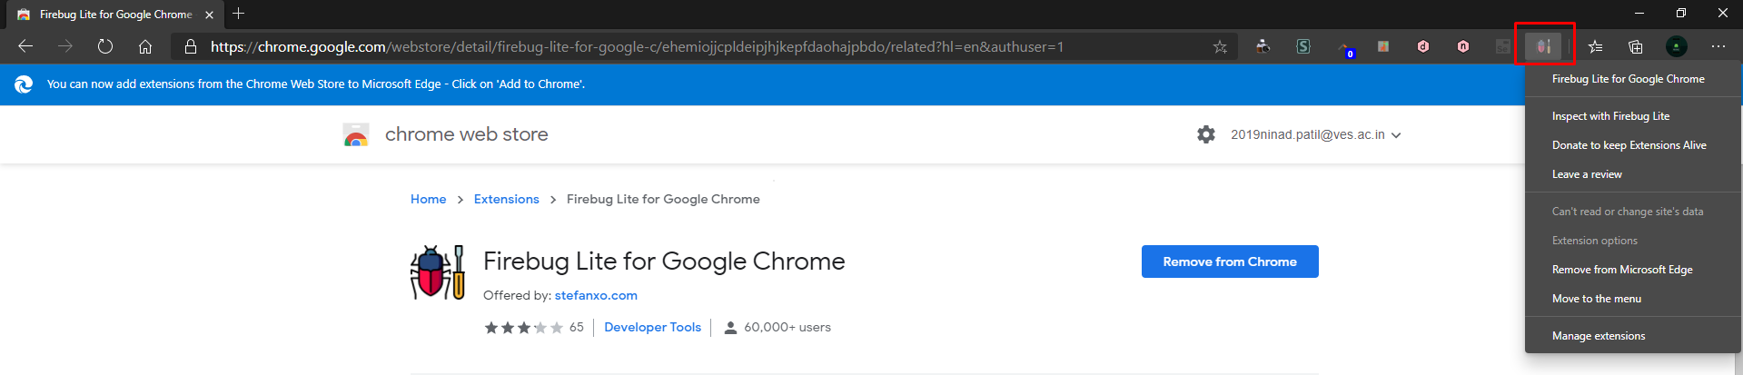

**Steps 4:** Click on Firebug Lite, it will launch Firebug Lite, its works similar as inspect elements.

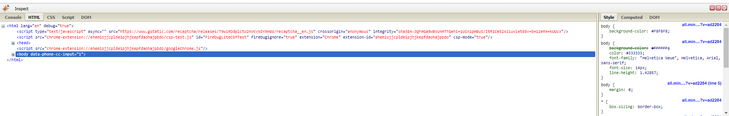

**Steps for installing Fire Path (ChroPath):**

**Steps 1:** Lunch Edge and then go to chrome web store search for ChroPath, then click on add to chrome as show in the image below.

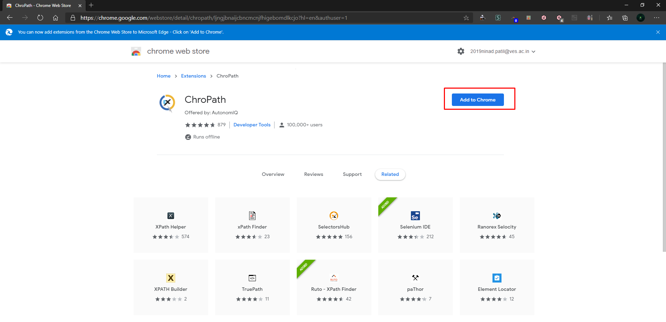

**Steps 2:** Edge will show one popup asking if you want to add extension or not. Click on Add extension button as show in image below.

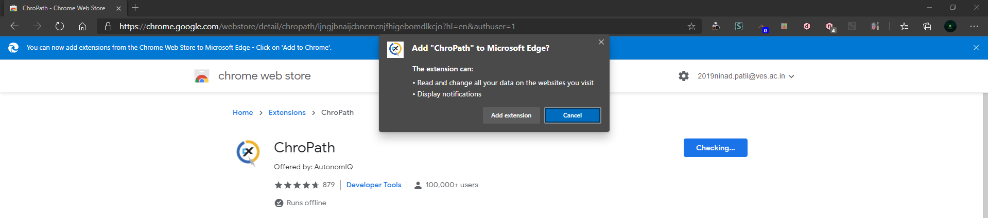

**Steps 3:** Edge will automatically add ChroPath extension. Once it added, we can see ChroPath on the toolbar menu. Click on that ChroPath (marked with red box) and it will open it.

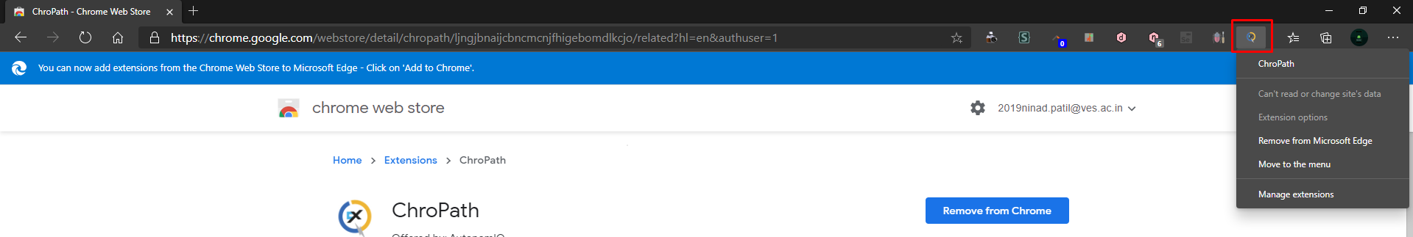

**Steps 4:** Now open firebug or press F12 to bring inspect element menu, then right click on inspect element and you could find the xpath as show in the image below.

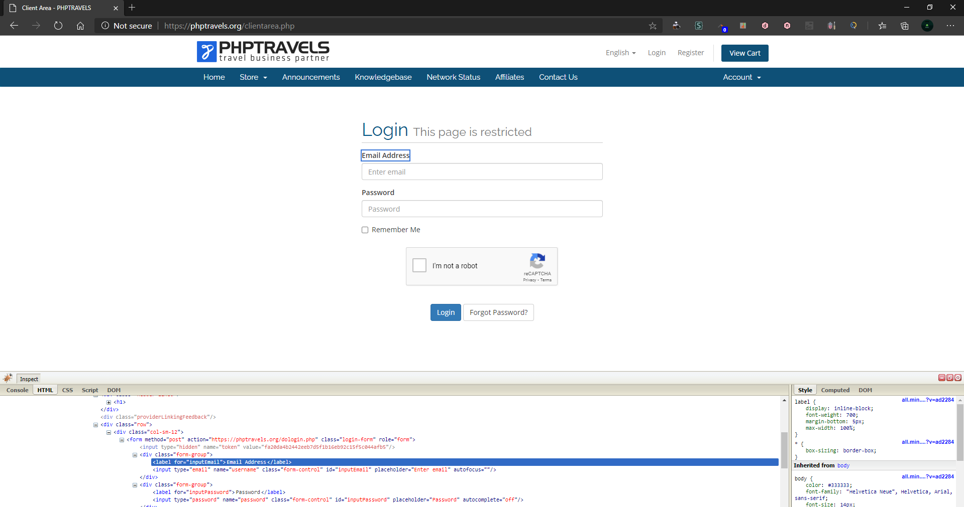

**Conclusion: We have successfully learned and installed Selenium IDE, Firebug Plug-in and Firepath (ChroPath).**